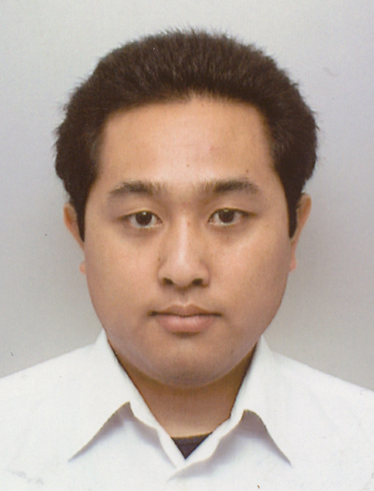
Self-Introduction
Name |  | Kojiro MATSUSHITA | Your Photo
Position |  | JSPS Research Fellow (PD) | Your Photo
Affiliation |  | Robot Locomotion Group, CSAIL, MIT, USA | Your Photo
Address |  | Office 32-380, 32 Vassar Street, Cambridge MA 02139, USA | Your Photo
Email |  | *********@********* | Your Photo
Web | (Lab) | http://groups.csail.mit.edu/locomotion/ | Your Photo
Web | (Private) | http://www.koj-m.sakura.ne.jp/ | Your Photo

Research Summary
[Title]
Please attach representative pictures
somewhere in the “Research Summary” box.

Representative Publications
- Kojiro Matsushita, Akihiro Yamakawa, Hiroshi Yokoi, Tamio Arai, A Case Study Approach: Walking Assist Scheme Exploiting Somatic Reflex of a Leg-Paralysis Patient, Journal of Robotics and Mechatronics, Vol.19, No.6, pp. 629-636, 2007.
- Kojiro Matsushita, Hiroshi Yokoi, Tamio Arai, Pseudo-Passive Dynamic Walkers Designed by Coupled Evolution of Controller and Morphology, Robotics and Autonomous Systems, Vol. 54, Issue 8, pp.674-685, 2006.

